CS3391 - Object Oriented Programming Subject Performance

## Performance Chart:

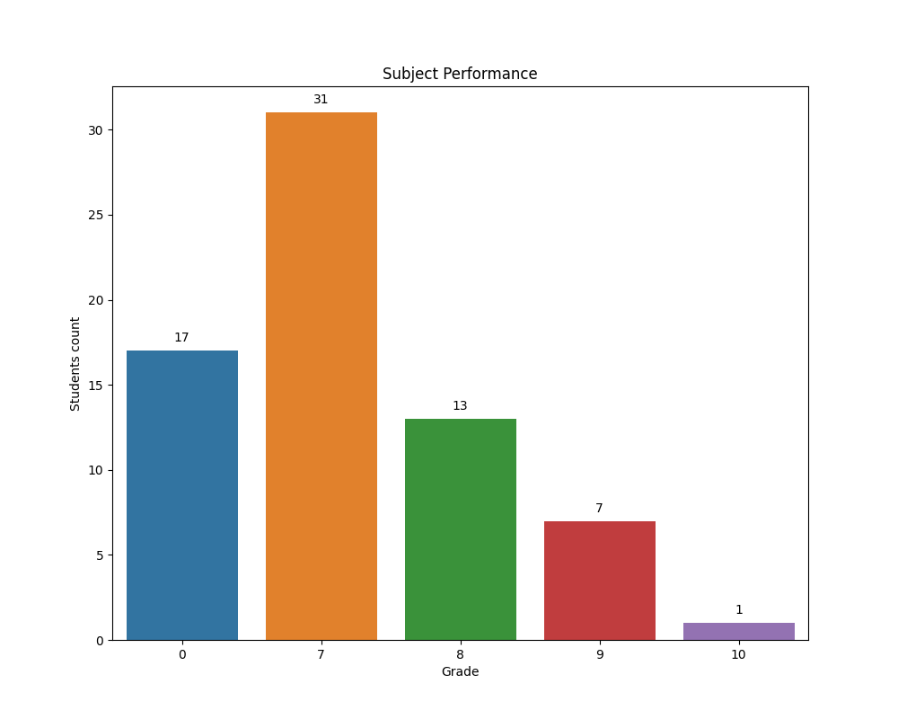

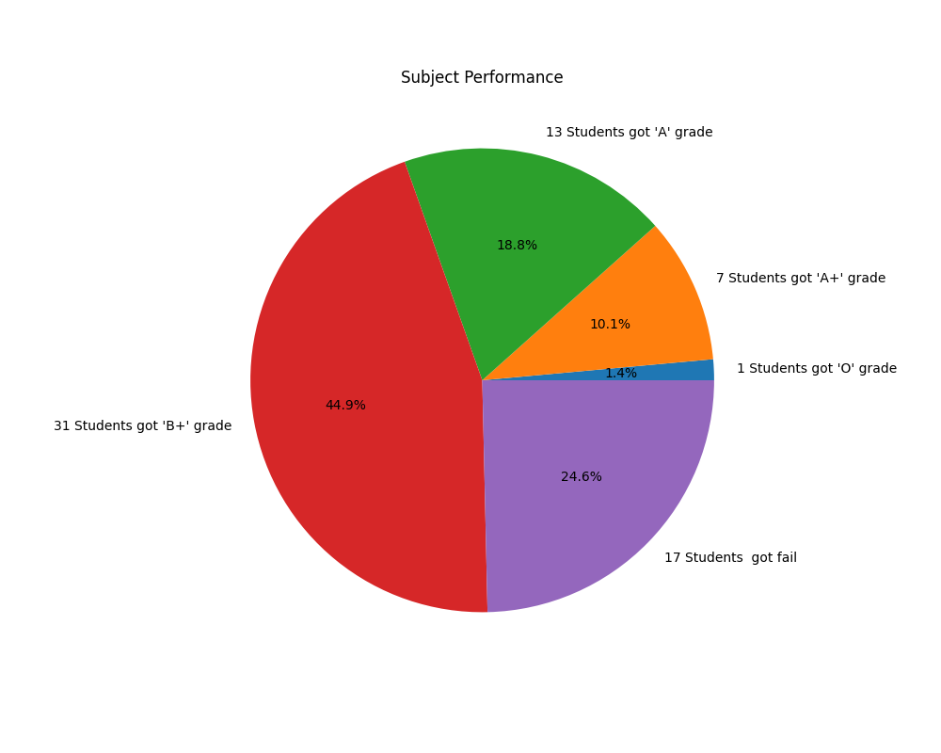

## Performance Summary:

The 1 Students got 'O' grade in the CS3391 Subject.  
 The 7 Students got 'A+' grade in the CS3391 Subject.  
 The 13 Students got 'A' grade in the CS3391 Subject.  
 The 31 Students got 'B+' grade in the CS3391 Subject.  
 The 17 Students got fail in the CS3391 Subject.

### Student Have O Grade:

PRIYADHARSHINI M

### Student Have A+ Grade:

AMBIRTHA N  
BALA SOWMIYA G  
DEVADHARSHINI K  
DIVYA D  
KOWSIKA A  
LAKSHANA S S  
VIMALRAJ P

### Student Have A Grade:

BAVADHARANI C  
DHANASHALINI S  
DHARANI S  
DINESH RAM S  
GAYATHRI J M  
JASWIN M  
KARTHICK V  
KIRTHIKA S S  
KOUSHIK R  
MERINKANTH N  
MOHAMMED ABDULLA A  
NIKITHA A  
RESHI S T

### Student Have B+ Grade:

AKASH S  
AMITHA KANISHMA J  
CHANDRU J  
DHANESHA A S  
DHANUSHIKA S  
DINESH T  
GUKAN R  
HANEEN S  
HARI PRASANTH S  
KANNAN T  
KIRUBAKARAN P  
KUMARESAN K R  
MALLISAVITHA M S K  
MANOJKUMAR K  
MEHANDHIGA M  
PIRTHIKA P N  
PRIYADHARSHINI K  
RANJITHKUMAR S  
SABARI NATHAN V  
SANDHIYA R  
SEENIVASAN G  
SEVVELKARAN PALANI  
VETRIVEL  
SHANKAR D  
SHRINIDHI S  
SIBIKA S  
SRIKAANTH V S  
SWATHI V  
SWETHA V  
VARSHINI R R  
YOGESWARI R  
THANARAJ S

### Student Have get Fail Grade:

ABHISHEK K A  
ABIRAMI S  
GIRIDHARAN K  
GOWTHAM K  
KANNAN S  
LOKESH P  
SAKTHIVEL R  
SANTHOSH M  
SRIKANTH R  
SRIKANTH S  
SUJAN M S  
UMA BHARATHI J  
VIMAL RAJ C  
HARIHARAN C  
JAHAN V  
NARESH S  
NEHRU PRASAD S R